
PATUAKHALI SCIENCE AND TECHNOLOGY UNIVERSITY
COURSE CODE CCE-211

SUBMITTED TO:

Prof. Dr. Md Samsuzzaman

Department of Computer and Communication Engineering
Faculty of Computer Science and Engineering

SUBMITTED BY:
Md. Sharafat Karim
ID: 2102024,
Registration No: 10151
Faculty of Computer Science and Engineering

Date of submission: 30 March, 2024
Assignment 01
Assignment title: Chapter 01
Q1-1. Identify the five components of a data communications system.
Five components are,
- Message
The information which will be delivered.
- Sender
The user or device who will deliver the message.
- Receiver
The user or device who will receive the message.
- Medium
The way in which message will be delivered.
- Protocol
The specific rules which will be maintained while delivering.
Q1-2. What are the three criteria necessary for an effective and efficient network?
Three necessary criteria for an effective network are,
- Performance
which refers to the transit and response time.
- Reliability
which refers to the frequency of failure.
- Security
which refers to the protection of data from unauthorized access.

Q1-3. What are the advantages of a multi-point connection over a point-to-point connection?
In a point-to-point connection, every device has dedicated connections, where in multi-point, devices share wires to establish a connection. So we need more wires to connect multiple devices altogether which increases the cost.
Besides managing more cables need more complex wire management, which makes the process more harder to troubleshoot. This is why multi-point connections are preferred.

Q1-4. What are the two types of line configuration?
The two types of line configurations are,
- Point-to-point configuration
In point-to-point every device has dedicated connections from a device to an another device.
- multi-point configuration
In multi-point, devices shares medium to establish a connection
Q1-5. Categorize the four basic topologies in terms of line configuration.
Topology | Line configuration
Bus | Multi-point
Star | Multi-point
Ring | Point-to-point
Mesh | Point-to-point

Q1-6. What is the difference between half-duplex and full-duplex transmission modes?
Half duplex
In a half-duplex data can transmit in both directions but not simultaneously. For example, wokitoki.
Full duplex
When one direction is being used then other direction has to pause. On the other hand in full-duplex data can transmit in both directions simultaneously. For example, real time simulations.
So full-duplex is much more practical in real life communications. But as both directional data has to pass, it can’t utilize the mediums full capacity when we need to communicate one by one. On the other hand half-duplex is more efficient when we need to pass data from one side to another at a time. In this case, the data can use the full capacity of the wire at a time. But it is not practical.

Q1-7. Name the four basic network topologies, and cite an advantage of each type.
Four basic network topologies with an advantage are,
- Mesh topology
It is much more faster than any other topologies.
- Star topology
We need little cable management for it and most used topology.
- Ring topology
We can identify faults more easily here.
- Bus topology
Bus topology is easy to install and extend new devices.

Q1-8. For n devices in a network, what is the number of cable links required for a mesh, ring, bus, and star topology?
Topology | Number of cable links
Bus | n - 1
Star | n
Ring | n
Mesh
Q1-9. What are some of the factors that determine whether a
communications system is a LAN or WAN?
The factors that determine whether a communications system is a LAN or WAN is the area that the system covers. For a smaller scale it is generally considered LAN and for the rest it is considered to be WAN.
Q1-10. What is an internet? What is the Internet?
An internet is two or more networks that can communicate with each other. On the other hand Internet is composed of thousand of interconnected networks.
Internet is the largest internet connection which covers the entire globe.
Q1-11. Why are protocols needed?
Protocols are some rules which defines how data is transmitted, received and interpreted. They make sure the three criteria for an effective communication.
Q1-12. In a LAN with a link-layer switch (Figure 1.8b), host 1 wants to send a message to host 3. Because communication is through the link-layer switch, does the switch need to have an address? Explain.
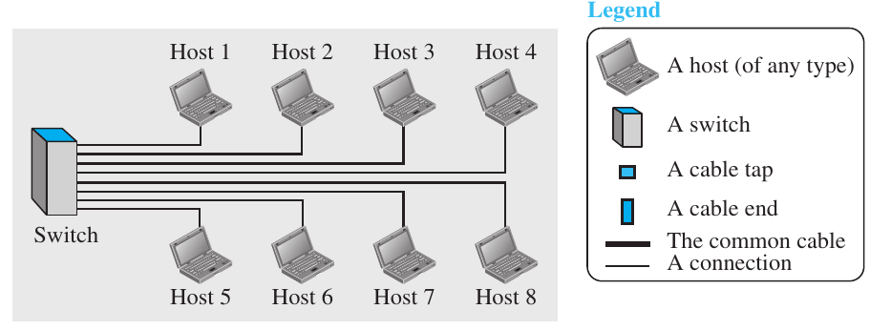
No, the link-layer switch doesn’t necessarily need to have an address. Switch simply forwards it’s message to every devices.
Q1-13. How many point-to-point WANs are needed to connect n LANs if each LAN should be able to directly communicate with any other LAN?
To connect n LAN’s if each should be able to directly communicate with any other LAN’s we need a mesh duplex connection. So we need points.

Q1-14. When a resident uses a dial-up or DLS service to connect to the Internet, what is the role of the telephone company?
The telephone company themselves need to connect to the WAN first. Then they use point-to-point WAN between the resident and the telephone center to connect to the Internet.
Q1-15 If there is a single path between the source host and the destination host, do we need a router between the two hosts?
We don’t necessarily need a router. Because we mainly use router to connect multiple WAN. So here we can directly connect them or can use a switch or a hum.
P1-1. What is the maximum number of characters or symbols that can be represented by Unicode?
Unicode has more than 1.1 million slot available, more precisely There are 1,111,998 possible Unicode characters.
P1-2. A color image uses 16 bits to represent a pixel. What is the maximum number of different colors that can be represented?
For 16 bits, maximum number of different color will be,
different colors.
P1-3. Assume six devices are arranged in a mesh topology. How many cables are needed? How many ports are needed for each device?
Cables needed,

and ports needed, (n-1) or, 5 ports.
P1-4. For each of the following four networks, discuss the consequences if a connection fails.
a. Five devices arranged in a mesh topology
b. Five devices arranged in a star topology (not counting the hub)
c. Five devices arranged in a bus topology
d. Five devices arranged in a ring topology
If a connection fails, the consequence will be,
Topology | If one cable fails
Bus | If one device connection breaks, other system will still be functional. But if the main connecting wire fails then the whole network will break from that point.
Star | If one connection fails, only the connected device will be effected.
Ring | If one connection fails, all connections will be disrupted from the broken point.
Mesh | If one connection fails, connection between the two devices for that specific cable will fail. Rest of the system will work flawlessly.
P1-5. In the ring topology in Figure 1.7, what happens if one of the
stations is unplugged?
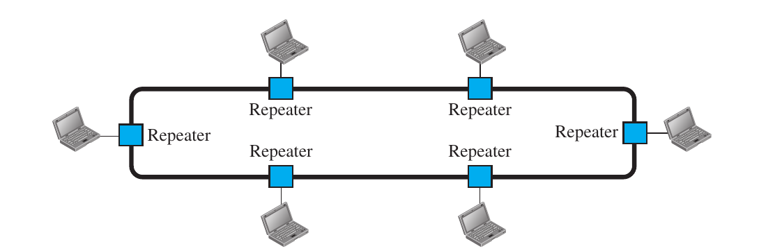
If one station is unplugged the rest of the system will stop working.
P1-6. In the bus topology in Figure 1.6, what happens if one of the stations is unplugged?
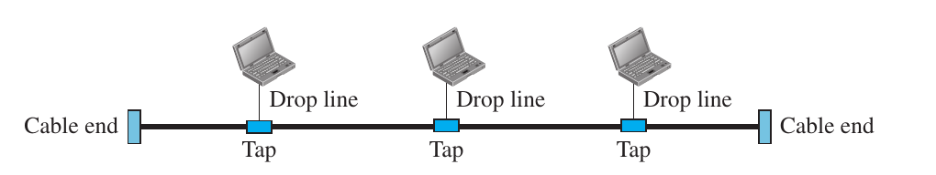
If one station is unplugged, then only the unplugged station will be effected. Rest of the system will work precisely.
P1-7. When a party makes a local telephone call to another party, is this a point-to-point or multipoint connection? Explain your answer.
It will be an point-to-point connection. In this case only these two parties are connected, so they can conduct a continuous connection. There’s no need for a signal to be delayed in the queue memory.
P1-8. Compare the telephone network and the Internet. What are
the similarities? What are the differences?
Both telephone and Internet allows customers to be connected through the WAN. Both of them connect people through specific protocol.
But in telephone networking only the voice communication is occurred, but in internet, simultaneously text, audio, video, image and numbers are transferred. So some telephone networking may use circuit-switched connections but Internet connection needs packet-switched connection.

